NetView Service Manual
Table of Contents
Netview Service Shortcuts

Defaults and Maintenance
Technician Maintenance

Processes
Repair Order Maintenance (ROM)
Open a Repair Order on a Customer Unit
Open a Repair Order on an Internal Unit
Open a Repair Order on a Warranty Unit
Open a Repair Order with no Unit
Open a Repair Order with a Dealer Assigned RO Number
Open a Repair Order with a System Assigned RO Number
Add Other Charges to an Existing Repair Order
Add Parts to an Existing Repair Order
Add Sublet Labor to an Existing Repair Order
Build Flat Rate Jobs
Use Flat Rate Jobs in a Repair Order
Close and Settle a Repair Order – Customer Pay
Close and Settle a Repair Order –Pay with Credit Card
Close and Settle a Repair Order –Internal
Repair Order History (ROH)
ROM/ROH: Service Audit Report
Time Slip Entry (TSE)
Entering Time from a Time Card
Technician Time Entry (TTE)
Clocking in on a Repair Order
Clocking out of a Repair Order

Service System

Menu Description | Brief Description | Shortcut
Gross Profit Report | View/Print Service Gross Profit Report | GPR
Labor Comeback Report | View/Print Report of Labor Comeback Details | LCR
Manufacturer Control Table Maintenance | Maintain Manufacturer Makes, GL Accounts, Sales Codes | MCTM
Reason Table Maintenance  Repair Order History  Repair Order Maintenance | Maintain Unapplied Time Reasons  View/Print Historical Repair Orders  Add/Maintain Repair Orders | RTM  ROH  ROM
Service Documents Pre-Journal  Service History Report  Service Options and Defaults  Service Productivity Report  Service System Post Journals | View/Print Proof Sheet of Unposted Service Entries  View/Print Service History by Customer or Unit  Maintain Service Options and Defaults  View/Print Productivity by Technician  Journalize Service System Entries | RDSS  SHR  SOD  SPR  SSPJ
Technician Maintenance  Technician Profitability Report  Technician Time Entry  Time Recap Report  Time Slip Entry  Time Slip Report | Add/Maintain Technician Information  View/Print Profitability by Technician and Invoice Type  Technician Clock In/Out of Repair Order  View/Print Report of Direct and Indirect Time  Maintain or Add Time Slips  View/Print Time Slip Report by Tech, RO and Date | TM  TPR  TTE  TRR  TSE  TSR
View Technician Work Activity | View/Print Technician Work Details | VTWA
Work In Process Report | View/Print Work In Process Report | WIP

TM

Technician Maintenance

Adding a Technician

- Type in TM in the Task Box

- Employee #
  - Enter the Employee #
  - If you have the payroll package, the technician must be added there first and then added here with the same number. If you do not have the payroll package, you may add a number of your choice here. The Arrow is available to look up existing technicians.

- Name
  - Enter the Technician’s name as First Name then Last Name
  - If the technician’s info is read from Payroll, the Name, Address and Telephone number fields will be pre-filled. We recommend that you change the Name to read First Name then Last Name

- Address fields
  - You may fill in the address, city, state/province, zip/postal code fields if desired

- Phone #’s
  - There are places for a regular phone, cell phone and another phone number. All of these are optional, but this is a great place to keep a list of contact numbers for each technician.

- Skill Level
  - This field is optional but can be used to choose a skill level for the technician. Make a selection from the pull down box. . These skills are created from the Skills button on the left panel. This button opens the maintenance screen where can levels and rates are defined.

- Cost
  - This field is optional but is used to provide costs for accounting entries and reports. It can only be edited with the button. The button is password-protected. The cost may be the technician’s actual cost or an average cost used for all technicians.

- Save
  - Save the record by clicking on the Save button on the left (Alt S).

ROM

Repair Order Maintenance

Open a Repair Order – Customer Unit

- Type ROM in the Task Box

- Service Writer ID #
  - Enter Service Writer ID #
  - You can also use the Arrow to look it up and click on the name with the mouse
  - Press Enter or Tab to accept

- Customer Number
  - Enter the Customer’s Number
    - You can also type in a portion of the name and look it up and click on the name with the mouse
  - Press Enter or Tab to accept
  - If you see a pop-up box of open repair orders for this customer, click on the New RO button to bypass it

- MOP
  - The Method of Payment (MOP) defaults from the Customer Master. This is only a suggested payment option. During Settlement, you will still have the chance to change it.
    - You can change the MOP default by using the pull down box to see the choices . Then use your mouse or the Up/Down arrow keys to select one
  - Press Enter or Tab to accept

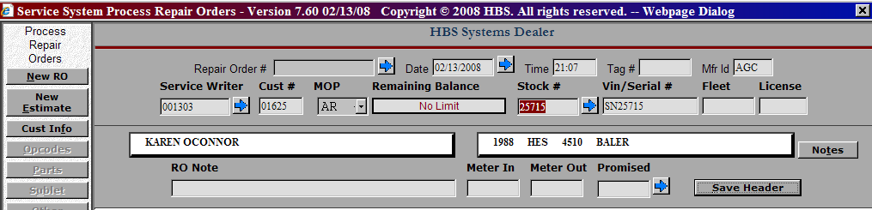

- Stock Number
- Enter the Stock number if known
    - You can use the Arrow to look up the Customer Goods for this customer number
      - Use your Mouse to find and click the desired Stock #.
      - This highlights the selected line in darker blue
      - Now, click the RO Select Button just above the Stock # list (or type Alt R)
    - If the unit is not present in the list, you can add it from here
      - Press Enter in Stock # Field to have the system assign the stock number or type in a stock number for the unit
        - Complete all information required by your dealership
        - With your mouse, click Save or type Alt S to save the unit
        - This stock number & information will then be written to RO header

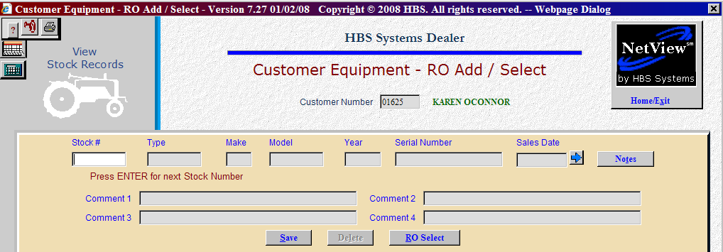

  - Opening Repairs w/o Stock Numbers
    - Skip the stock # field
    - Enter a Short Description in VIN/Serial# Field
      - This will print on the Tech Copy and Invoice

- Tag #, Fleet & License are currently informational fields only – not required

- Meter In/Out or Promised Date
  - Enter information required by your dealership – these will print on Tech Copy & Invoice

- Press the Save Header button or type Alt S

- RO # has been assigned (you will see it grayed out in the top of the header)
- Short Description (fill in a brief description of the repair needed)
  - Description – You may fill in more details of the repair needed if desired
  - Labor Sales Code
- These codes will default from the Customer Master
- Change/select only if needed using drop down boxes or arrows

  - Parts Price Code
  - Parts Sales Code
  - Parts Tax Code
  - Save Record (or type Alt V)

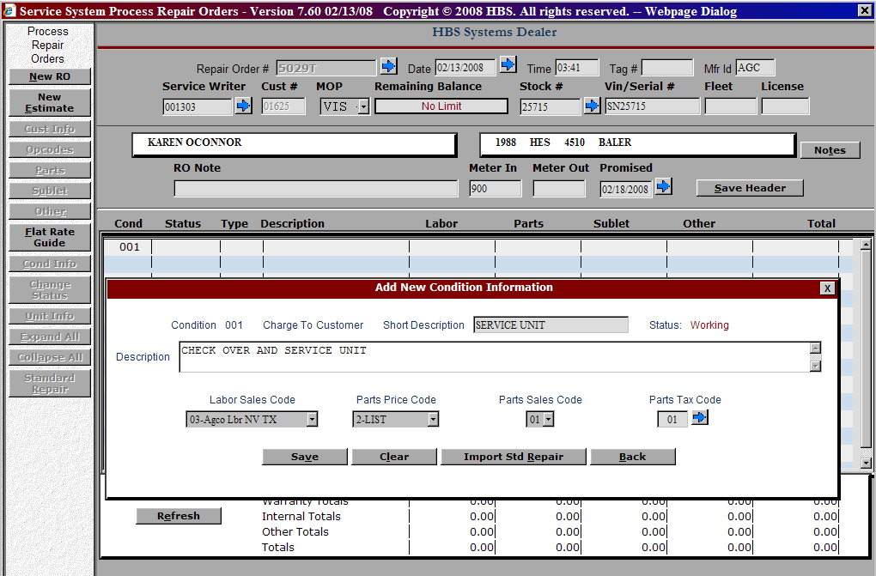

- Use your mouse and click on Condition 001 to expand the window and add the opcode.
  - OPCODE - Use your mouse and click on Opcode
    - This opens a pop-up box where you can enter or select an Opcode & save it (or type Alt S)

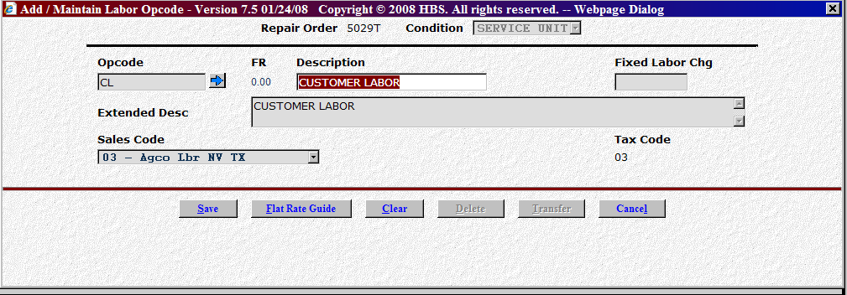

    - If you do not know the Opcode, use the Arrow to search for it
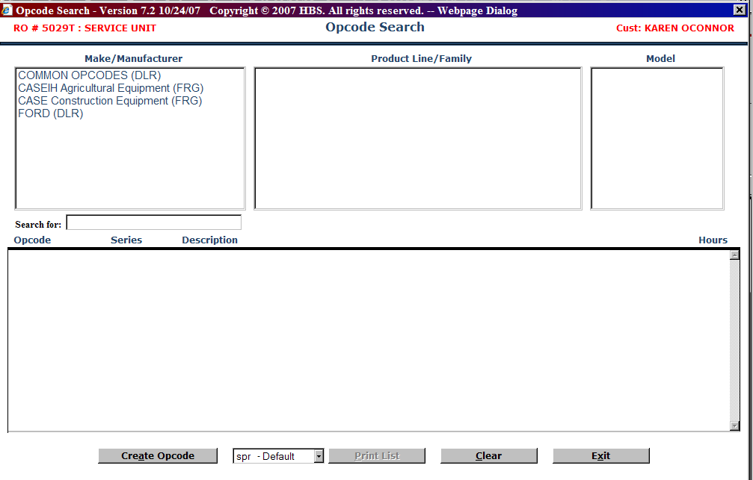
    - Use your mouse and click Common Opcodes (DLR)
    - Click on the desired Opcode from the list and a pop-up box appears with the details.
      - A Fixed Labor amount can be entered now if required
      - –OR- Time Slips will accumulate when Techs clock in/out of this RO, Condition & Opcode
    - Click the Save button (or type Alt S)

- Print the Tech Copy (Hard Copy) – Click on the Print Tech Copy button or type Alt H

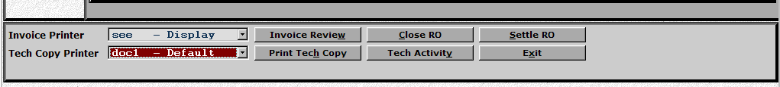

ROM

Repair Order Maintenance

Open a Repair Order – Internal Unit

- Type ROM in the Task Box

- Service Writer ID #
  - Enter Service Writer ID #
  - You can also use the Arrow to look it up and click on the name with the mouse
  - Press Enter or Tab to accept

- Customer Number
  - Enter Customer 00004 (or your default customer #)
  - Press Enter or Tab to accept
  - If you see a pop-up box of open repair orders appear, click on the New RO button to bypass it

- MOP
  - The Method of Payment (MOP) field will show INT for this Internal Repair Order
  - Press Enter or Tab to accept

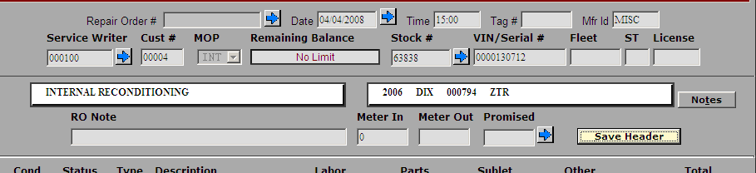

- Stock Number
- Enter the Stock number if known
    - You can use the Arrow to access the Unit Inquiry screen to look up the unit
      - Use your Mouse to find and click the desired Stock #.
      - You will be returned to the Unit Inquiry screen where that unit will be shown. To use this unit for the repair order, simply press the Home/Exit button (or type Alt X).

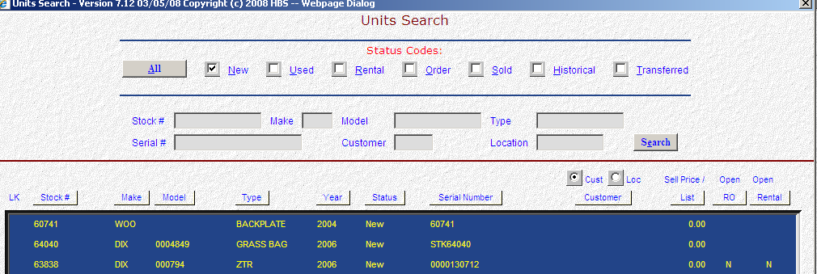

  - Opening Repairs w/o Stock Numbers
    - Skip the stock # field
    - Enter a Short Description in VIN/Serial# Field
      - This will print on the Tech Copy and Invoice

- Tag #, Fleet & License are currently informational fields only – not required

- Meter In/Out or Promised Date
  - Enter information required by your dealership – these will print on Tech Copy & Invoice

- Press the Save Header button or type Alt S

- RO # has been assigned (you will see it grayed out in the top of the header)
- Short Description (fill in a brief description of the repair needed)
  - Description – You may fill in more details of the repair needed if desired
  - Labor Sales Code
- These codes will default from the Customer Master
- Change/select only if needed using drop down boxes or arrows

  - Parts Price Code
  - Parts Sales Code
  - Parts Tax Code
  - Save Record (or type Alt V)

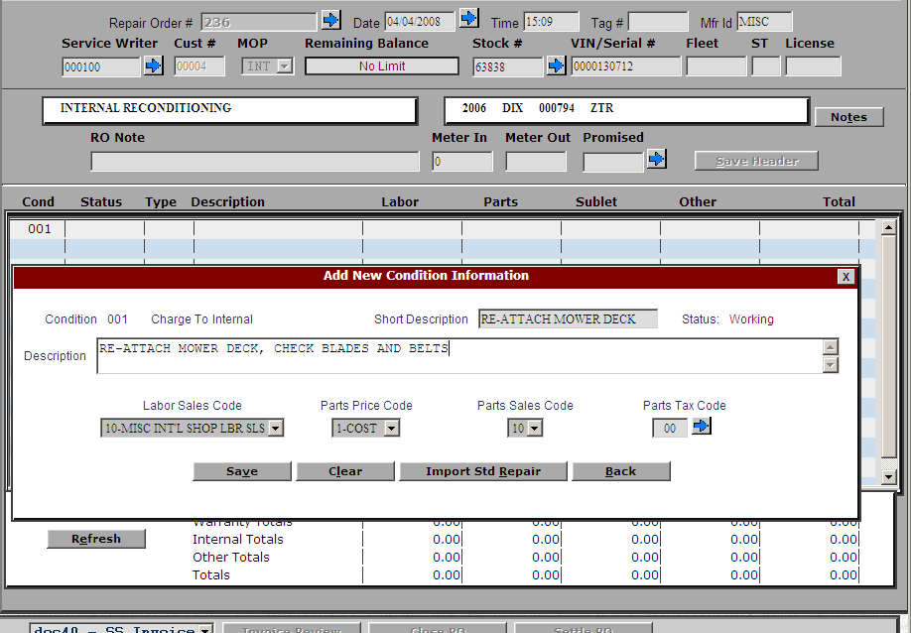

- Use your mouse and click on Condition 001 to expand the window and add the opcode.
  - OPCODE - Use your mouse and click on Opcode
    - This opens a pop-up box where you can enter or select an Opcode & save it (or type Alt S)

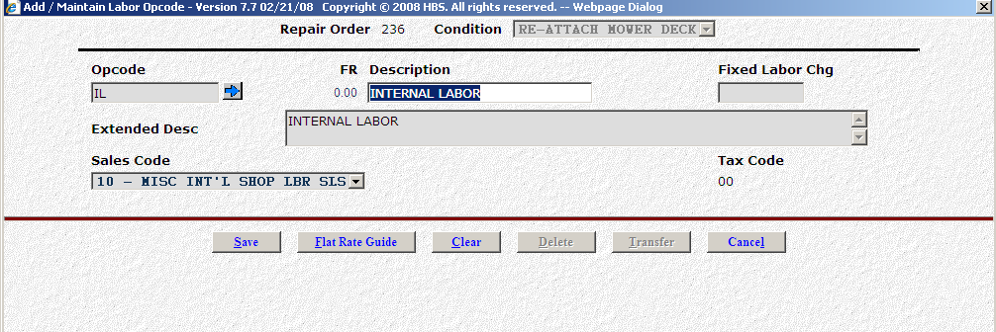

    - If you do not know the Opcode, use the Arrow to search for it

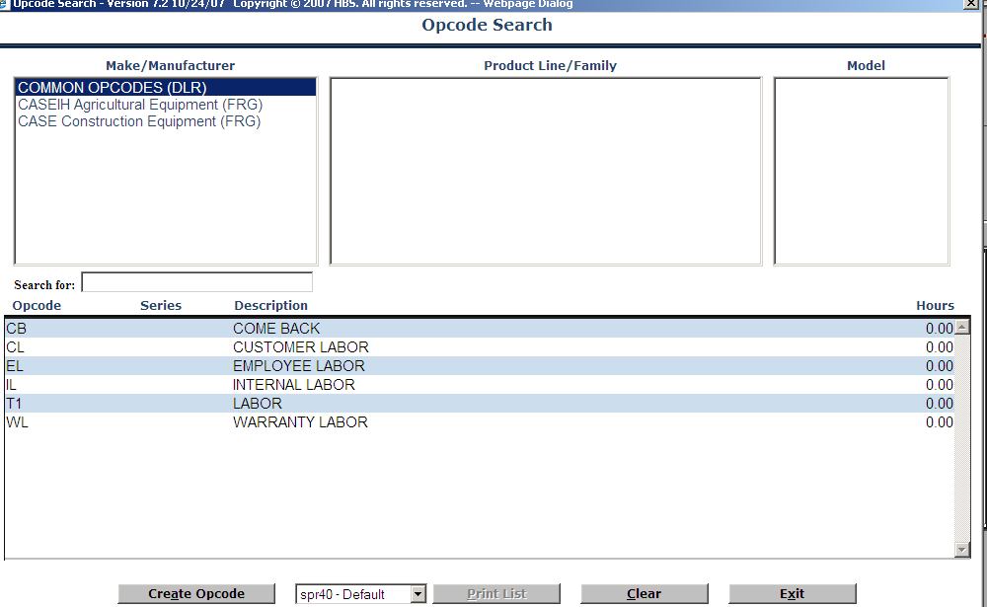

    - Use your mouse and click Common Opcodes (DLR)
    - Click on the desired Opcode from the list and a pop-up box appears with the details.
      - A Fixed Labor amount can be entered now if required
      - –OR- Time Slips will accumulate when Techs clock in/out of this RO, Condition & Opcode
    - Click the Save button (or type Alt S)

- Print the Tech Copy (Hard Copy) – Click on the Print Tech Copy button or type Alt H



ROM

Repair Order Maintenance

Open a Repair Order – Warranty Unit

- Type ROM in the Task Box

- Service Writer ID #
  - Enter Service Writer ID #
  - You can also use the Arrow to look it up and click on the name with the mouse
  - Press Enter or Tab to accept

- Customer Number
  - Enter Customer 00007
  - Press Enter or Tab to accept
  - If you see a pop-up box of open repair orders appear, click on the New RO button to bypass it

- MOP
  - The Method of Payment (MOP) field will show WAR for this Warranty Repair Order
  - Press Enter or Tab to accept

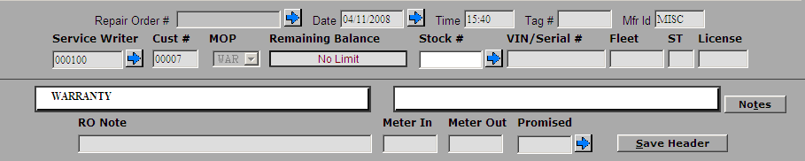

- Stock Number
- Enter the Stock number if known
    - You can use the Arrow to access the Unit Inquiry screen to look up the unit
      - Use your Mouse to find and click the desired Stock #.
      - You will be returned to the Unit Inquiry screen where that unit will be shown. To use this unit for the repair order, simply press the Home/Exit button (or type Alt X).



- Tag #, Fleet & License are currently informational fields only – not required

- Meter In/Out or Promised Date
  - Enter information required by your dealership – these will print on Tech Copy & Invoice

- Press the Save Header button or type Alt S

- RO # has been assigned (you will see it grayed out in the top of the header)
- Short Description (fill in a brief description of the repair needed)
  - Description – You may fill in more details of the repair needed if desired
  - Labor Sales Code
- These codes will default from the Customer Master
- Change/select only if needed using drop down boxes or arrows

  - Parts Price Code
  - Parts Sales Code
  - Parts Tax Code
  - Save Record (or type Alt V)

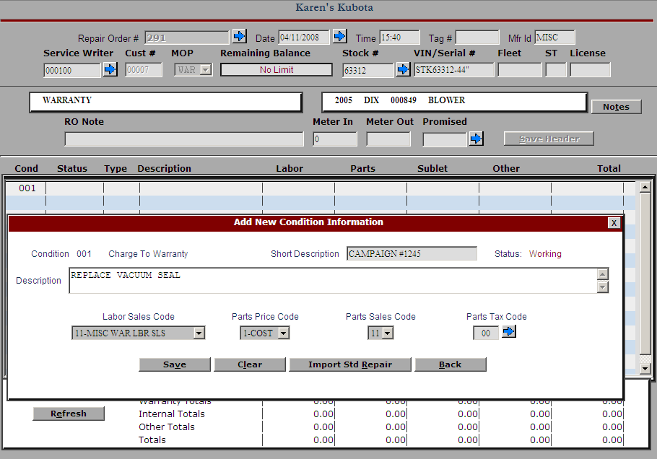

- Use your mouse and click on Condition 001 to expand the window and add the opcode.
  - OPCODE - Use your mouse and click on Opcode
    - This opens a pop-up box where you can enter or select an Opcode & save it (or type Alt S)

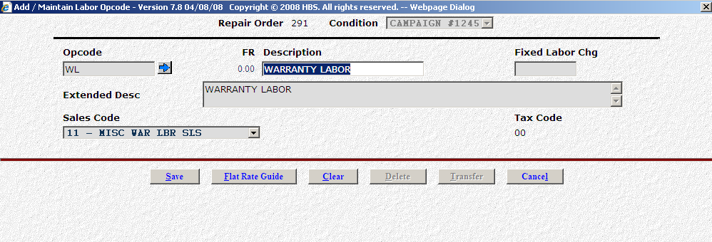

    - If you do not know the Opcode, use the Arrow to search for it



    - Use your mouse and click Common Opcodes (DLR)
    - Click on the desired Opcode from the list and a pop-up box appears with the details.
      - A Fixed Labor amount can be entered now if required
      - –OR- Time Slips will accumulate when Techs clock in/out of this RO, Condition & Opcode
    - Click the Save button (or type Alt S)

- Print the Tech Copy (Hard Copy) – Click on the Print Tech Copy button or type Alt H



ROM

Repair Order Maintenance

Open a Repair Order – NO Unit

- Type ROM in the Task Box

- Service Writer ID #
  - Enter Service Writer ID #
  - You can also use the Arrow to look it up and click on the name with the mouse
  - Press Enter or Tab to accept

- Customer Number
  - Enter the Customer’s Number
    - You can also type in a portion of the name and look it up and click on the name with the mouse
  - Press Enter or Tab to accept
  - If you see a pop-up box of open repair orders for this customer, click on the New RO button to bypass it

- MOP
  - The Method of Payment (MOP) defaults from the Customer Master. This is only a suggested payment option. During Settlement, you will still have the chance to change it.
    - You can change the MOP default by using the pull down box to see the choices . Then use your mouse or the Up/Down arrow keys to select one
  - Press Enter or Tab to accept



- Skip the Stock Number, Serial #/Vin #, Fleet and License fields
    - You may use the RO note field to document some of the details of the item being repaired. This will print on the Tech Copy and Invoice

- Press the Save Header button or type Alt S

- RO # has been assigned (you will see it grayed out in the top of the header)

- Short Description (fill in a brief description of the repair needed)
  - Description – You may fill in more details of the repair needed if desired. This is also a good place to put in details of the item being repaired
  - Labor Sales Code
- These codes will default from the Customer Master
- Change/select only if needed using drop down boxes or arrows

  - Parts Price Code
  - Parts Sales Code
  - Parts Tax Code
  - Save Record (or type Alt V)


- Use your mouse and click on Condition 001 to expand the window and add the opcode.
  - OPCODE - Use your mouse and click on Opcode
    - This opens a pop-up box where you can enter or select an Opcode & save it (or type Alt S)



    - If you do not know the Opcode, use the Arrow to search for it


    - Use your mouse and click Common Opcodes (DLR)
    - Click on the desired Opcode from the list and a pop-up box appears with the details.
      - A Fixed Labor amount can be entered now if required
      - –OR- Time Slips will accumulate when Techs clock in/out of this RO, Condition & Opcode
    - Click the Save button (or type Alt S)

- Print the Tech Copy (Hard Copy) – Click on the Print Tech Copy button or type Alt H



ROM

Repair Order Maintenance

Open a Repair Order – Dealer Assigned RO Numbers

- Type ROM in the Task Box

- Repair Order Number
  - Enter the RO # from a paper RO document
  - Press Enter or Tab to accept

- Service Writer ID #
  - Enter Service Writer ID #
  - You can also use the Arrow to look it up and click on the name with the mouse
  - Press Enter or Tab to accept

- Customer Number
  - Enter the Customer’s Number
    - You can also type in a portion of the name and look it up and click on the name with the mouse
  - Press Enter or Tab to accept
  - If you see a pop-up box of open repair orders for this customer, click on the New RO button to bypass it

- MOP
  - The Method of Payment (MOP) defaults from the Customer Master. This is only a suggested payment option. During Settlement, you will still have the chance to change it.
    - You can change the MOP default by using the pull down box to see the choices . Then use your mouse or the Up/Down arrow keys to select one
  - Press Enter or Tab to accept

- Stock Number
- Enter the Stock number if known
    - You can use the Arrow to look up the Customer Goods for this customer number
      - Use your Mouse to find and click the desired Stock #.
      - This highlights the selected line in darker blue
      - Now, click the RO Select Button just above the Stock # list (or type Alt R)
    - If the unit is not present in the list, you can add it from here
      - Press Enter in Stock # Field to have the system assign the stock number or type in a stock number for the unit
        - Complete all information required by your dealership
        - With your mouse, click Save or type Alt S to save the unit
        - This stock number & information will then be written to RO header



  - Opening Repairs w/o Stock Numbers
    - Skip the stock # field
    - Enter a Short Description in VIN/Serial# Field
      - This will print on the Tech Copy and Invoice

- Tag #, Fleet & License are currently informational fields only – not required

- Meter In/Out or Promised Date
  - Enter information required by your dealership – these will print on Tech Copy & Invoice
- Press the Save Header button or type Alt S
- Short Description (fill in a brief description of the repair needed)
  - Description – You may fill in more details of the repair needed if desired
  - Labor Sales Code
- These codes will default from the Customer Master
- Change/select only if needed using drop down boxes or arrows

  - Parts Price Code
  - Parts Sales Code
  - Parts Tax Code
  - Save Record (Alt V)

- Print the Tech Copy (Hard Copy) – Click on the Print Tech Copy button or type Alt H


ROM

Repair Order Maintenance

Open a Repair Order – System Assigned RO Numbers

- Type ROM in the Task Box

- Service Writer ID #
  - Enter Service Writer ID #
  - You can also use the Arrow to look it up and click on the name with the mouse
  - Press Enter or Tab to accept

- Customer Number
  - Enter the Customer’s Number
    - You can also type in a portion of the name and look it up and click on the name with the mouse
  - Press Enter or Tab to accept
  - If you see a pop-up box of open repair orders for this customer, click on the New RO button to bypass it

- MOP
  - The Method of Payment (MOP) defaults from the Customer Master. This is only a suggested payment option. During Settlement, you will still have the chance to change it.
    - You can change the MOP default by using the pull down box to see the choices . Then use your mouse or the Up/Down arrow keys to select one
  - Press Enter or Tab to accept



- Stock Number
- Enter the Stock number if known
    - You can use the Arrow to look up the Customer Goods for this customer number
      - Use your Mouse to find and click the desired Stock #.
      - This highlights the selected line in darker blue
      - Now, click the RO Select Button just above the Stock # list (or type Alt R)
    - If the unit is not present in the list, you can add it from here
      - Press Enter in Stock # Field to have the system assign the stock number or type in a stock number for the unit
        - Complete all information required by your dealership
        - With your mouse, click Save or type Alt S to save the unit
        - This stock number & information will then be written to RO header



  - Opening Repairs w/o Stock Numbers
    - Skip the stock # field
    - Enter a Short Description in VIN/Serial# Field
      - This will print on the Tech Copy and Invoice

- Tag #, Fleet & License are currently informational fields only – not required

- Meter In/Out or Promised Date
  - Enter information required by your dealership – these will print on Tech Copy & Invoice
- Press the Save Header button or type Alt S
- RO # has been assigned (you will see it grayed out in the top of the header)
- Short Description (fill in a brief description of the repair needed)
  - Description – You may fill in more details of the repair needed if desired
  - Labor Sales Code
- These codes will default from the Customer Master
- Change/select only if needed using drop down boxes or arrows

  - Parts Price Code
  - Parts Sales Code
  - Parts Tax Code
  - Save Record (Alt V)



- Print the Tech Copy (Hard Copy) – Click on the Print Tech Copy button or type Alt H

ROM

Repair Order Maintenance

Add Other Charges to an Existing Repair Order

- Type ROM in the Task Box

- Access an Existing Repair Order
  - Press the New RO button or type Alt N
    - Type in the Repair Order #
  - –OR- press the Arrow to look it up
  - Press Enter or Tab to accept

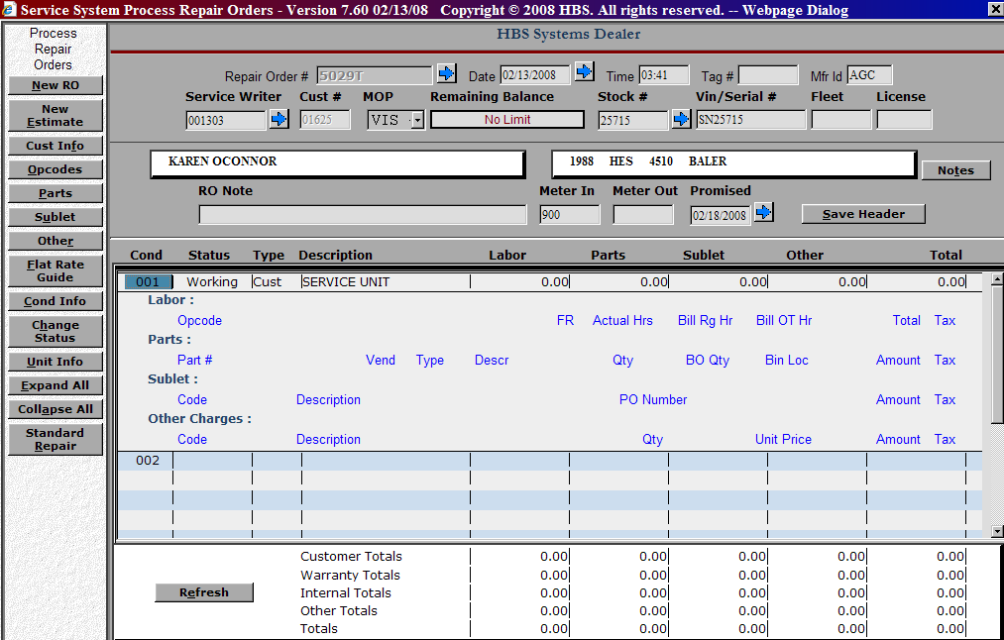

- Use your mouse and click on Condition 001 to expand the window
OTHER CHARGES - Use your mouse and click on Code under Other Charges
    - Enter the Other Charge code or use the pull down box to select from the list.
      - Using your mouse or the arrow keys to highlight the code.
      - Enter the quantity or press Enter through the default of 1.
      - Fill in the unit price (price x quantity entered = extended amt)
        - The tax code is read from the Customer Master – change if necessary
      - Click on Save (Alt S) and the click on Exit (Alt X) when done to return to the ROM screen

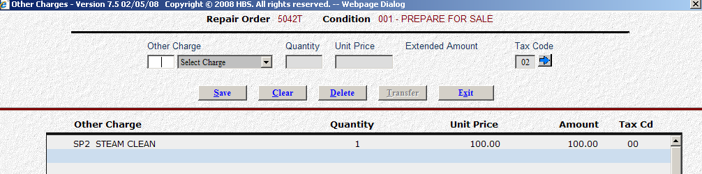

ROM

Repair Order Maintenance

Add Parts to an Existing Repair Order

- Type ROM in the Task Box

- Access an Existing Repair Order
  - Press the New RO button or type Alt N
    - Type in the Repair Order #
  - –OR- press the Arrow to look it up
  - Press Enter or Tab to accept



- Use your mouse and click on Condition 001 to expand the window
- PARTS - Use your mouse and click on Part #
  - This takes you to a POS screen
      - Enter your salesman initials/number
      - Add parts to the RO
        - Parts can be placed on B/O just as in POS
        - Parts can be imported through a pick list from a catalog like EPIC, PAL. Solutions, etc. (parts imported no longer have to be in inventory or on-hand)
      - Click on Exit when done to return to the ROM screen

ROM

Repair Order Maintenance

Add Sublet Labor to an Existing Repair Order

- Type ROM in the Task Box

- Access an Existing Repair Order
  - Press the New RO button or type Alt N
    - Type in the Repair Order #
  - –OR- press the Arrow to look it up
  - Press Enter or Tab to accept



- Use your mouse and click on Condition 001 to expand the window
- SUBLET - Use your mouse and click on Code under Sublet
  - Enter the Sublet code or use the pull down box to select from the list.
    - Using your mouse or the arrow keys to highlight the code.
    - The cursor stops for a P.O. Number – so you can enter info if required
    - Enter Dealer Cost if provided and system will handle mark up
    - -OR- Enter a Fixed Amount to charge for sublet
      - The tax code is read from the Customer Master – change if necessary
    - Enter an extended description if desired
    - Click on Save (Alt S) and the click on Exit (Alt X) when done to return to the ROM screen

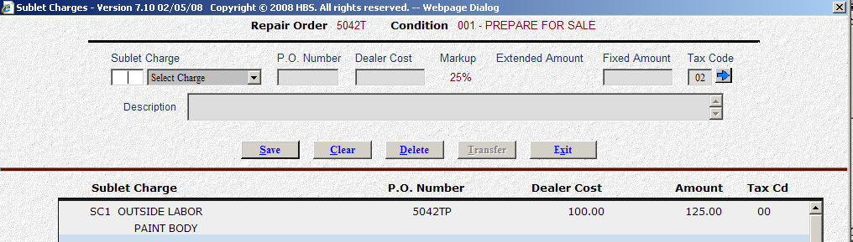

ROM

Repair Order Maintenance

Build Flat Rate Jobs

- Type ROM in the Task Box

- Click on the New Estimate button

- Service Writer ID #
  - Enter Service Writer ID #
  - You can also use the Arrow to look it up and click on the name with the mouse
  - Press Enter or Tab to accept

- Customer Number
  - Enter Customer 00004 if you are creating an Internal job, Customer 00007 for a Warranty job or 00000 if you are creating a Customer job
  - Press Enter or Tab to accept
  - If you see a pop-up box of open repair orders appear, click on the New RO button to bypass it

- MOP
  - The Method of Payment (MOP) defaults from the Customer Master. This is only a suggested payment option. During Settlement, you will still have the chance to change it.
    - You can change the MOP default by using the pull down box to see the choices . Then use your mouse or the Up/Down arrow keys to select one
  - Press Enter or Tab to accept

- RO Note
  - You may optionally fill in “Use this RO for building Flat Rate Jobs”
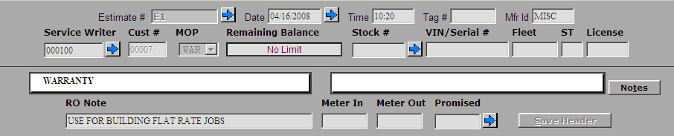

- Press the Save Header button or type Alt S
- Short Description (fill in a brief description of the Flat Rate Job)
  - Description – You may fill in more details of the repair needed if desired
  - Labor Sales Code
- These codes will default from the Customer Master
- Change/select only if needed using drop down boxes or arrows

  - Parts Price Code
  - Parts Sales Code
  - Parts Tax Code
  - Save Record (or type Alt V)
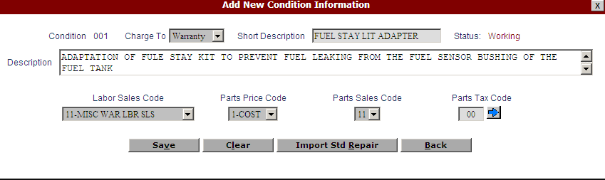
- Use your mouse and click on Condition 001 to expand the window and add the opcode.
  - OPCODE - Use your mouse and click on Opcode
    - This opens a pop-up box where you can enter or select an Opcode & save it (or type Alt S)
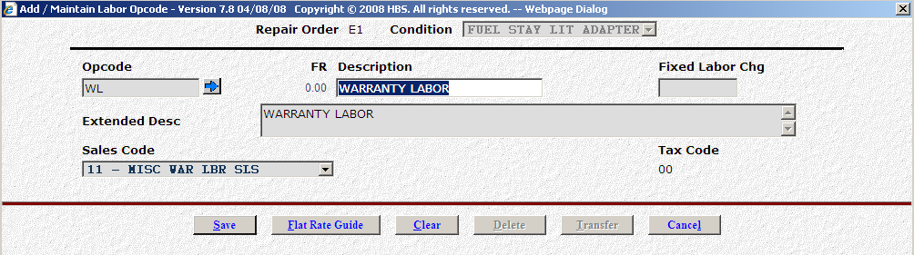
If you do not know the Opcode, use the Arrow to search for it



    - Use your mouse and click Common Opcodes (DLR)
    - Click on the desired Opcode from the list and a pop-up box appears with the details.
      - A Fixed Labor amount can be entered now if required
      - –OR- Time Slips will accumulate when Techs clock in/out of this RO, Condition & Opcode
    - Click the Save button (or type Alt S)

- PARTS - Use your mouse and click on Part #
  - This takes you to a POS screen
      - Enter your salesman initials/number
      - Add parts to the Flat Rate Job
        - Parts can be imported through a pick list from a catalog like EPIC, PAL. Solutions, etc. (parts imported no longer have to be in inventory or on-hand)
      - Click on Exit when done to return to the ROM screen

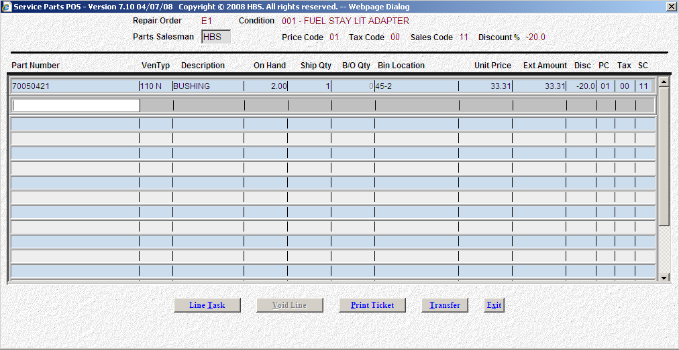

- When finished with all details for the Flat Rate Job, use your mouse and click on Condition Info on the left side of the screen.
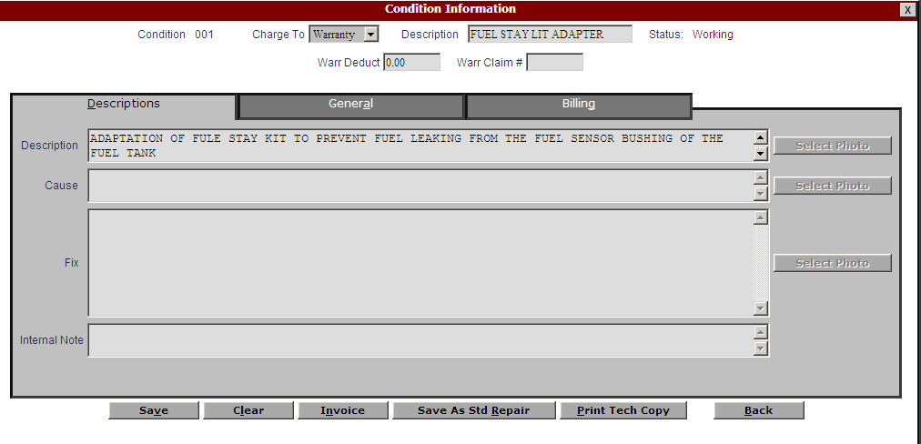
  - Click on Save As Std Repair or type Alt R to save the Flat Rate Job
    - Type in a name for the Flat Rate Job in the field called Std Repair ID and press the Save button (or type Alt V)
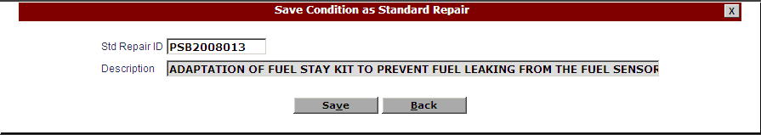

ROM

Repair Order Maintenance

Use Flat Rate Jobs

- Type ROM in the Task Box

- Service Writer ID #
  - Enter Service Writer ID #
  - You can also use the Arrow to look it up and click on the name with the mouse
  - Press Enter or Tab to accept

- Customer Number
  - Enter Customer 00004 if you are creating an Internal job, Customer 00007 for a Warranty job or 00000 if you are creating a Customer job
  - Press Enter or Tab to accept
  - If you see a pop-up box of open repair orders appear, click on the New RO button to bypass it

- MOP
  - The Method of Payment (MOP) defaults from the Customer Master. This is only a suggested payment option. During Settlement, you will still have the chance to change it.
    - You can change the MOP default by using the pull down box to see the choices . Then use your mouse or the Up/Down arrow keys to select one
  - Press Enter or Tab to accept

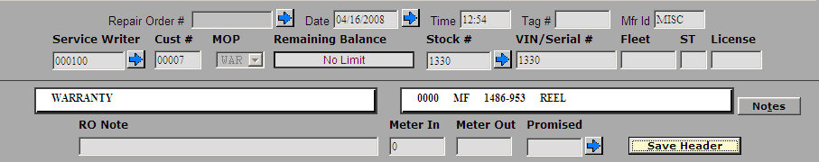

- Press the Save Header button or type Alt S
- On the Add New Condition Window, click on the Import Std Repair button or type Alt R
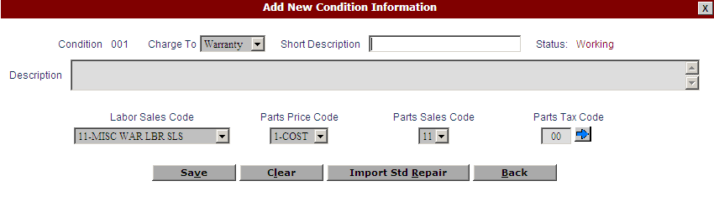

- Choose a Flat Rate Job from the screen or use the search feature to located the desired one. Click on it and then click on the Add to R/O button or type Alt A.
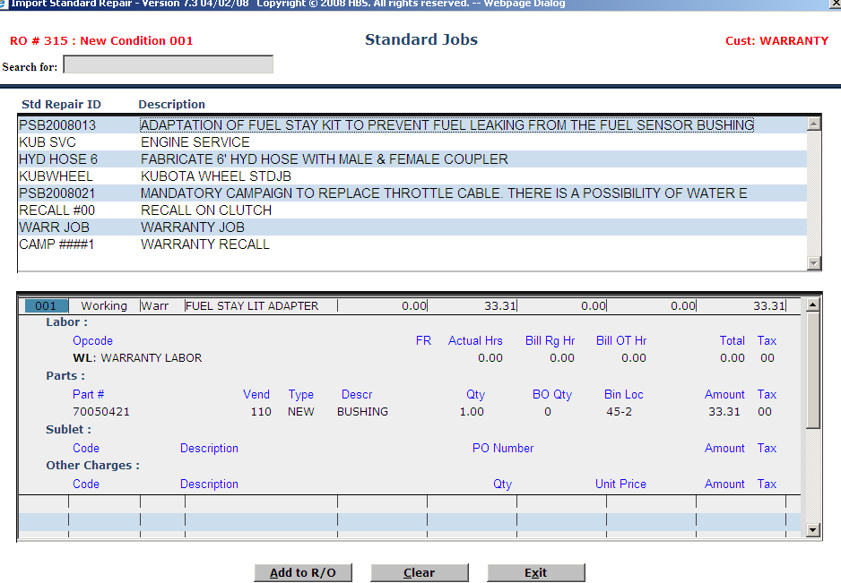
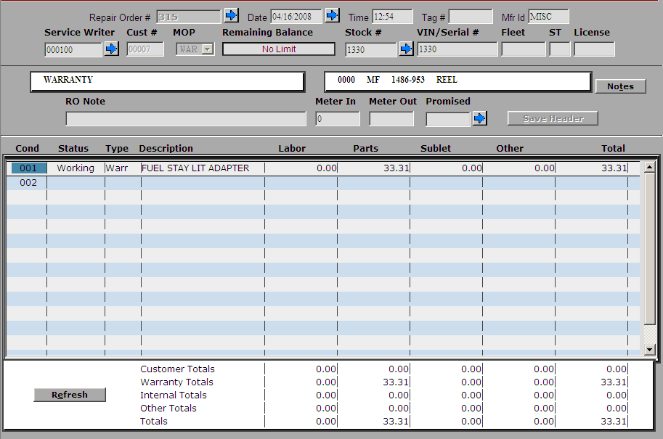
You have successfully imported a Flat Rate Job into your new repair order.

ROM

Repair Order Maintenance

Close, Invoice, Settle & Post a Repair Order

- Type ROM in the Task Box

- Access an Existing Repair Order
  - Press the New RO button or type Alt N
    - Type in the Repair Order #
  - –OR- press the Arrow to look it up
  - Press Enter or Tab to accept

- Use your mouse and click on Condition 001 to expand the window

  - Review Labor
    - Use your mouse to click on hours under Bill Rg Hr
    - A pop-up box of all time slips on this RO/Condition/Opcode appears
      - Time Slip Tab – View all times slips by tech
      - View/Adjust Technicians Billable Time Tab – Click on a Tech to change billed hours as needed – Reg, O/T, Double, Triple, etc. & then click on Save (Alt S) & Exit (Alt X)
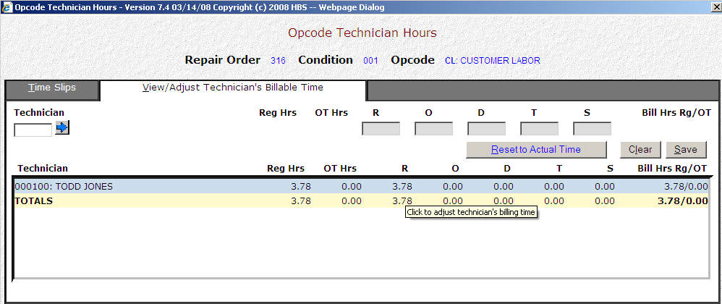

  - Invoice Review
    - Preview Invoice prior to printing
      - Select the “see” printer to display your invoice with totals to the screen
      - Select a printer to get a printout

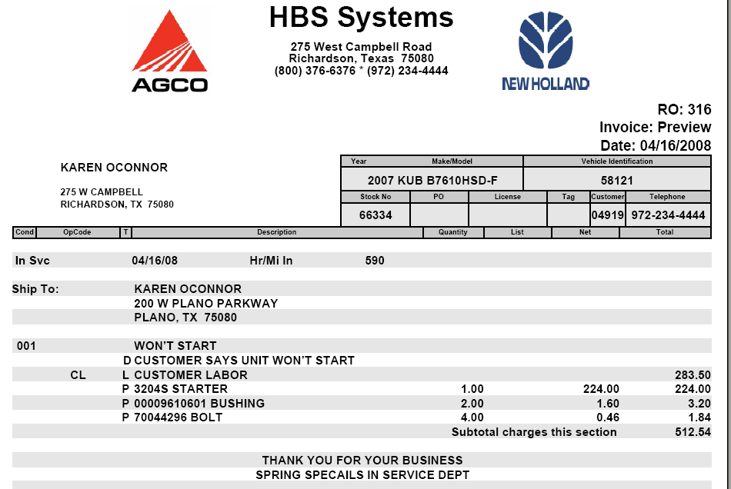

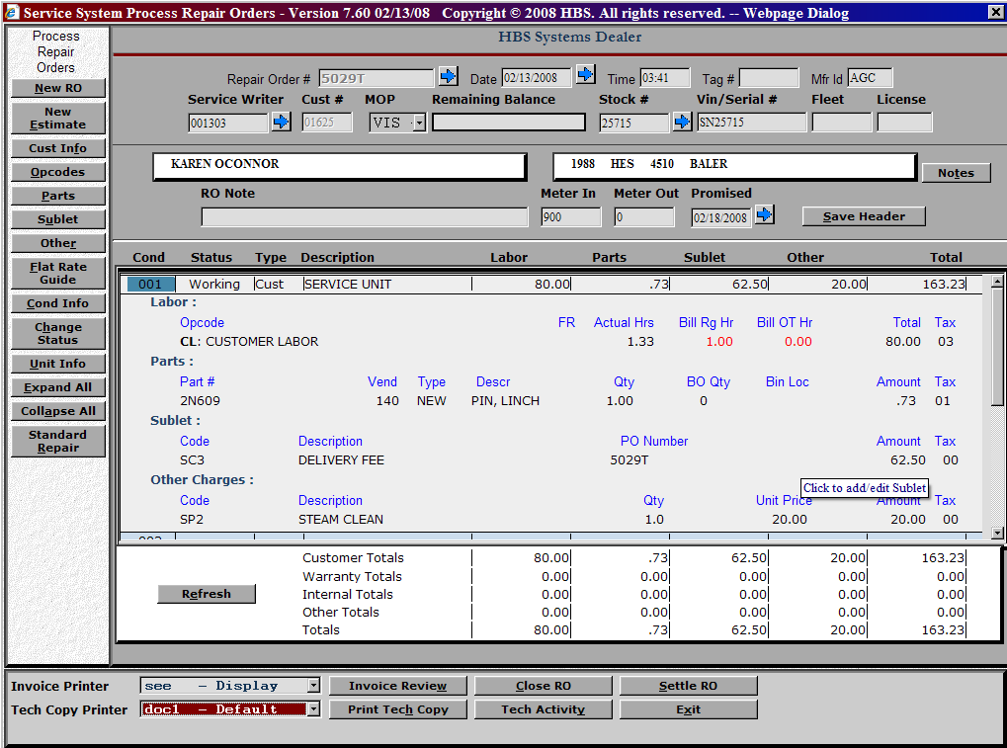

  - Settle
    - Click on the Settle RO button
    - Click on the All Charge Types button in the center of the screen
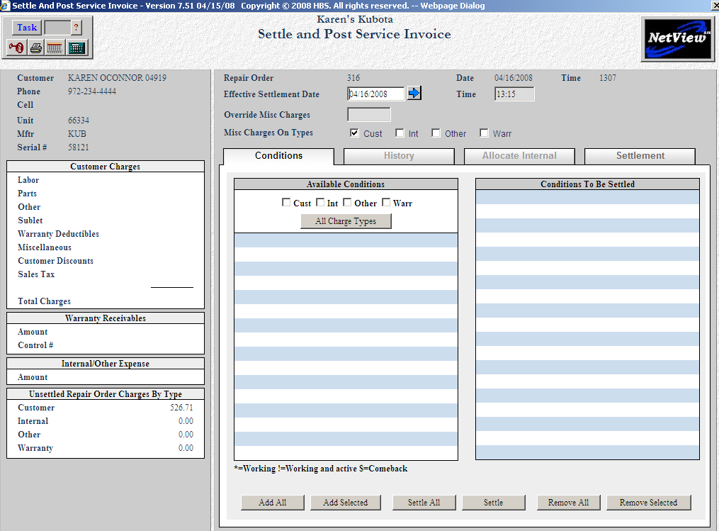

    - Click on the Settle All button at the bottom of the screen
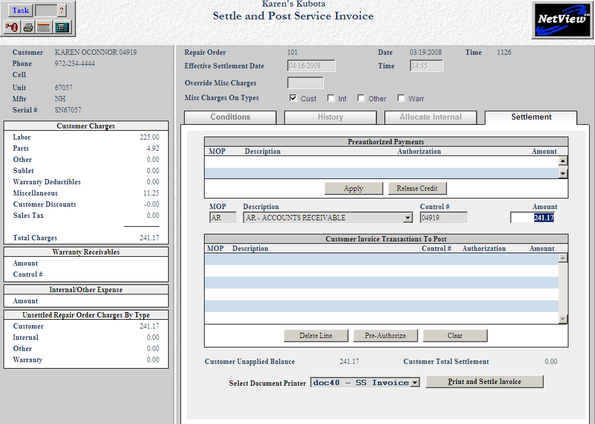

    - Verify the method of payment and amount in the center of the screen.
      - If it is ok, press the Print and Settle button on the bottom of the screen. Check your invoice and press Yes to say it printed ok.
      - If you need to change the method of payment, press the enter key so the line shown moves to the box below.
        - Click on that line to select it and use the pull down box for the description to select another form of payment.
        - Enter a Control # if necessary and verify the amount.
        - Press the Print and Settle button on the bottom of the screen. Check your invoice and press Yes to say it printed ok.
ROM

Repair Order Maintenance

Close & Settle a Repair Order – Pay with Credit Card

- Type ROM in the Task Box

- Access an Existing Repair Order
  - Press the New RO button or type Alt N
    - Type in the Repair Order #
  - –OR- press the Arrow to look it up
  - Press Enter or Tab to accept

- Use your mouse and click on Condition 001 to expand the window

  - Review Labor
    - Use your mouse to click on hours under Bill Rg Hr
    - A pop-up box of all time slips on this RO/Condition/Opcode appears
      - Time Slip Tab – View all times slips by tech
      - View/Adjust Technicians Billable Time Tab – Click on a Tech to change billed hours as needed – Reg, O/T, Double, Triple, etc. & then click on Save (Alt S) & Exit (Alt X)


  - Invoice Review
    - Preview Invoice prior to printing
      - Select the “see” printer to display your invoice with totals to the screen
      - Select a printer to get a printout





  - Settle
    - Click on the Settle RO button
    - Click on the All Charge Types button in the center of the screen


    - Click on the Settle All button at the bottom of the screen
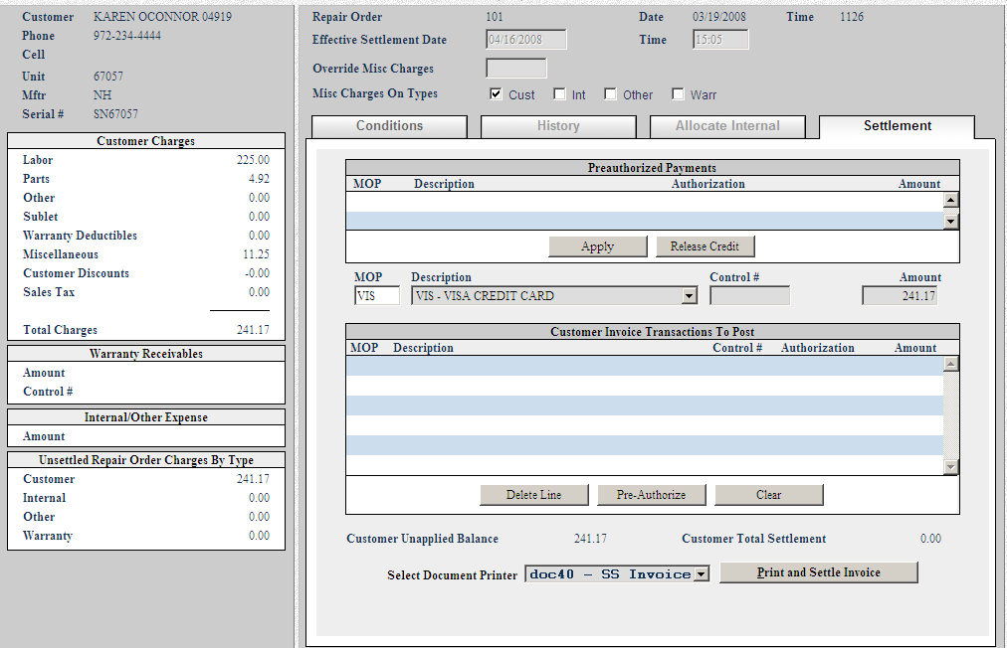

    - Press Enter or Tab through the Control # and Amount fields on the Credit Card Payment line.
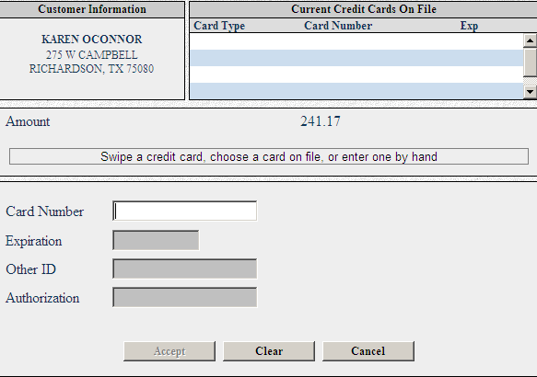

      - Select a credit card from the list at the top of the screen, if any, -OR- swipe the credit card –OR- or enter the card number and expiration date.
        - If the credit card communications package is installed you will messages about the progress of the authorization.
        - If not, you will fill in the authorization number from your manual credit card machine.
      - Press the Print and Settle button on the bottom of the screen. Check your invoice and press Yes to say it printed ok.

ROM

Repair Order Maintenance

Close & Settle a Repair Order – Internal

- Type ROM in the Task Box

- Access an Existing Repair Order
  - Press the New RO button or type Alt N
    - Type in the Repair Order #
  - –OR- press the Arrow to look it up
  - Press Enter or Tab to accept

- Use your mouse and click on Condition 001 to expand the window

  - Review Labor
    - Use your mouse to click on hours under Bill Rg Hr
    - A pop-up box of all time slips on this RO/Condition/Opcode appears
      - Time Slip Tab – View all times slips by tech
      - View/Adjust Technicians Billable Time Tab – Click on a Tech to change billed hours as needed – Reg, O/T, Double, Triple, etc. & then click on Save (Alt S) & Exit (Alt X)


  - Invoice Review
    - Preview Invoice prior to printing
      - Select the “see” printer to display your invoice with totals to the screen
      - Select a printer to get a printout

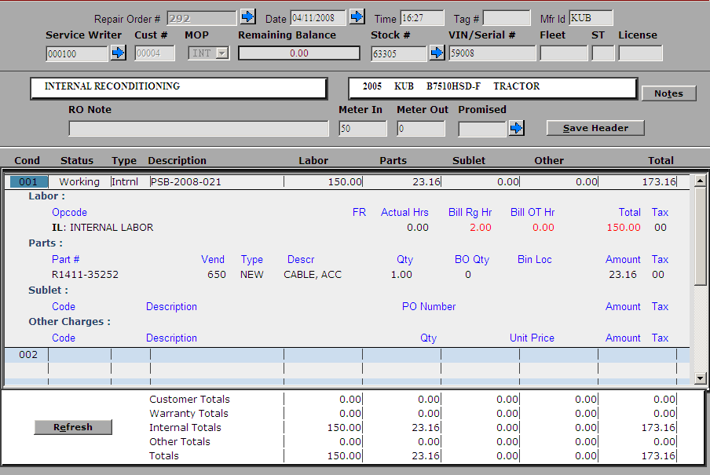

  - Settle
    - Click on the Settle RO button
    - Click on the All Charge Types button in the center of the screen
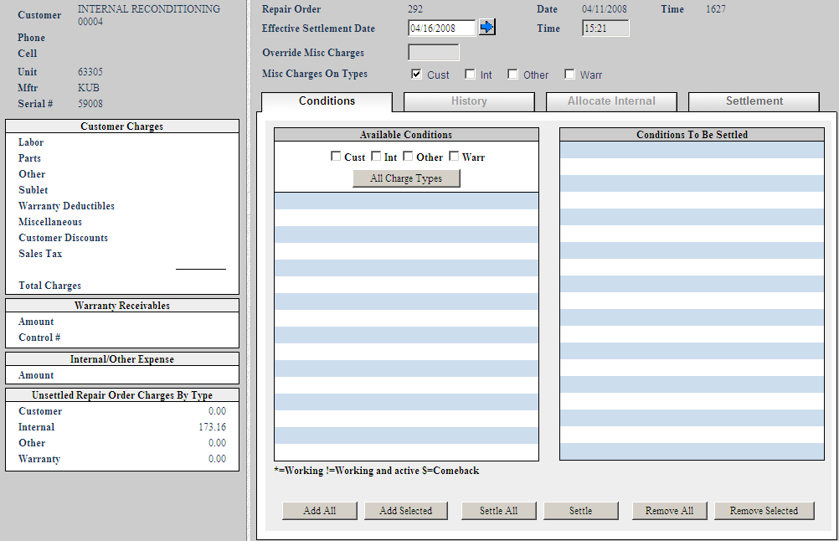

    - Click on the Settle All button at the bottom of the screen

    - If there are no special accounting needs, press the Print and Settle button on the bottom of the screen. Check your invoice and press Yes to say it printed ok.

    - If you need to adjust the accounting, click on the Allocate Internal Tab in the center of the screen.

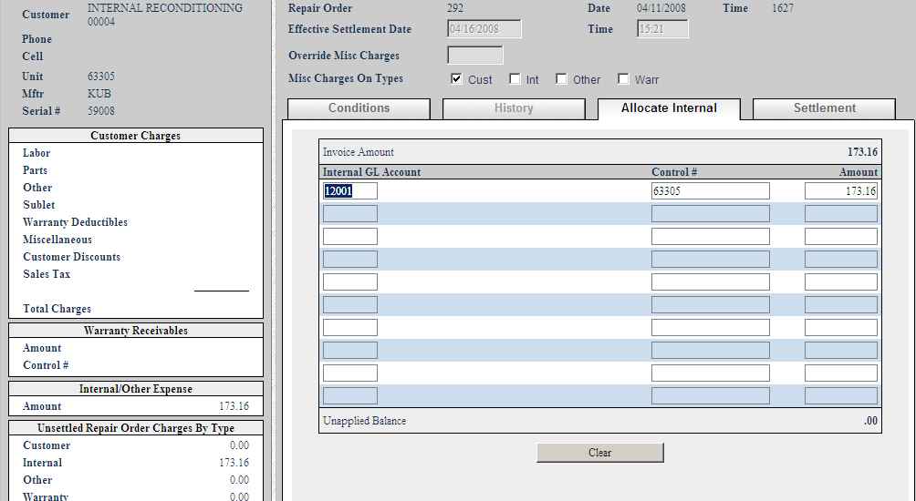

      - Verify or change the G/L account number shown. You may have up to ten G/L accounts referenced on this screen. You may type in the G/L account in the leftmost field or type in a portion of the account number to look it up. Make sure the Unapplied Balance is .00 before continuing.

      - Click on the Settlement tab

      - Press the Print and Settle button on the bottom of the screen. Check your invoice and press Yes to say it printed ok.

Repair Order History (ROH)

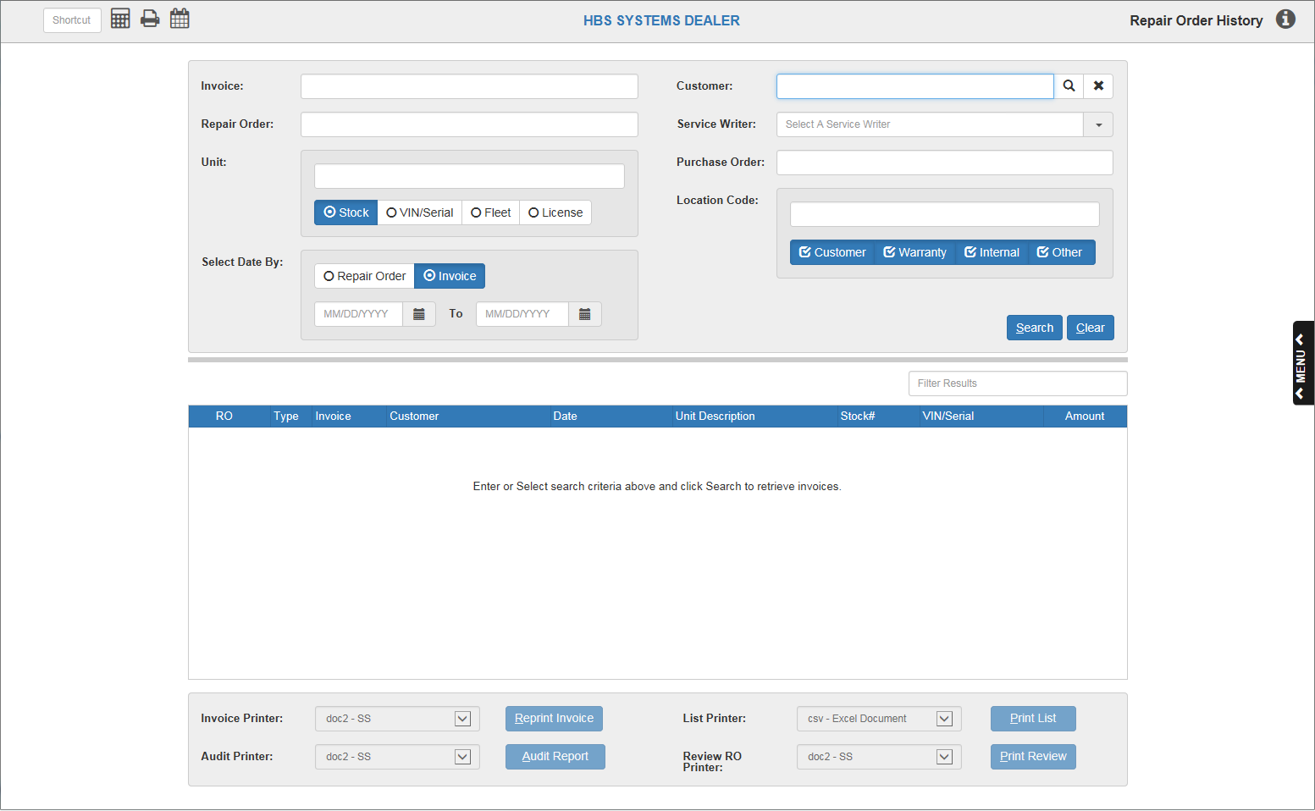

Repair Order History (ROH) allows you to view older repair orders that have been closed and stored in your history.

- To access this program, you can:
  - Type “ROH” into the Shortcuts Bar.
  - Select “Service” from the menu and click “Repair Order History.”

Field Definitions

Invoice: To search by invoice number, type the invoice number in this field.

Customer: To search by customer, type the customer number in this field.

- To clear the field, click the “X” icon beside it.
- Customer Search: You can also search for a customer by all or part of their name in this field and clicking the Search icon.
  - The following screen will appear:

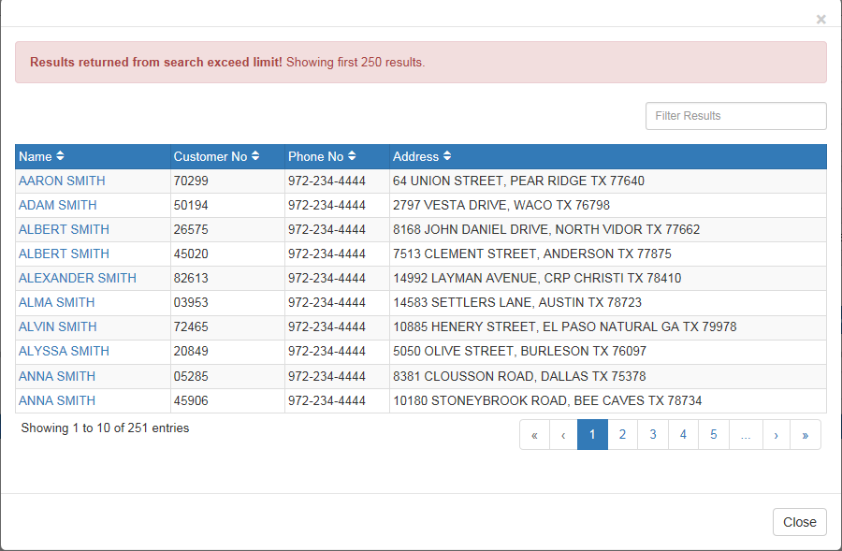

  - Click the customer’s name if you see it on the first page of results.
  - If you do not see the customer’s name, use the search tools to locate it.
    - Page Numbers: Use the page numbers and arrows to navigate between pages of results.
    - Filter Bar: Use the Filter Bar in the upper right-hand corner to narrow down your results by entering in more specific information, such as:
      - More of the customer’s name
      - All or part of the customer number
      - All or part of the customer’s phone number
      - All or part of the customer’s address
  - Once you have selected a customer’s name, their information will populate the Customer field like so:

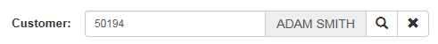

Repair Order: To search by repair order number, type the number into this field.

Service Writer: To search by service writer, type either the service writer’s name or number in this field.

- Once you begin typing, a drop-down menu listing potential service writers by their number and name will appear below the field.

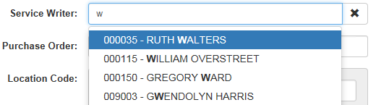

- Type until you see the service writer you’re looking for, then select their name from the menu.
- Once you’ve selected your writer, the information will fill in the field as shown below:

- To clear the field, click the “X” icon to the right of the field.

Unit: To search for by unit, select one of the unit ID types listed below the field and type the associated number into the field. The number could be one of the following:

- Stock number
- VIN/Serial number
- Fleet number
- License number

Select Date By: Use this feature to search for repair orders created within a set of dates.

- Choose whether the document is a Repair Order or Invoice.
- Set the date range by either:
  - Typing the starting and ending dates into the two fields.
  - Using the Calendar icon by each field to select a date, which will automatically fill into the field(s).
    - Year Feature: This search allows you to automatically enter the first and last dates of a year by simply typing that year into the first and second fields, respectively. This then lets you search for all orders created during that year.

Purchase Order: To search by purchase order number, type the number in this field.

Location Code: To search by location code, type the code in this field and select one or more types to which it applies (you can select up to all four at the same time). The types are:

- Customer
- Warranty
- Internal
- Other

Search: Once you have typed in your desired search criteria, click “Search.” You can also simply click “Search” to pull up all the available records in the application. If the search finds any results, they will fill the Results Box below.

Clear: To clear any filled-in search fields of their information, click “Clear.”

Results Box: This information box will list the information of any orders returned by a search.

Filter Bar: Use the Filter Bar above the box’s right corner to narrow down your results by typing in further information that might be listed in one of the box’s columns, such as the RO number or the customer’s name. You will receive results for even partial information, like a first name or half of an order number.

Sortable Headers: Use the column headers to sort the data by various criteria, depending on the header used. See “Column Definitions” below for how each header sorts the information.

Column Definitions:

- RO: The repair order number will appear in this column. The column header sorts the data numerically by RO number, both ascending and descending.
- Type: The order’s type will appear in this column. The column header sorts the data alphabetically or reverse alphabetically by the type letter.
- Invoice: The order’s invoice number will appear in this column. The column header sorts the data numerically by invoice number, both ascending and descending.
- Customer: The customer’s name will appear in this column. The column header sorts the data alphabetically or reverse alphabetically by the first letter of the first name.
- Date: The order’s date will appear in this column. The column header sorts the data chronologically or reverse chronologically by date.
- Unit Description: The unit description will appear in this column. The column header sorts the data in the following ascending order (with everything reversed if done descending):
  - Entries with no description (appear last if sorted in reverse)
  - Numerically by first number in description (descending numeric order when sorted in reverse)
  - Alphabetically by first letter in description if there are no numbers (reverse alphabetically before the descending numbers when sorted in reverse)
- Stock#: The unit’s stock number will appear in this column. The column header sorts the data numerically by stock number, both ascending and descending.
- VIN/Serial: The unit’s VIN/serial number will appear in this column. The column header sorts the data numerically by VIN/serial number, both ascending and descending.
- Amount: The dollar amount of the order will appear in this column. The column header sorts the data numerically by dollar amount, both ascending and descending.

Printing: The application provides three different printing methods through which you may print one or more of your orders.

Invoice Printer/Reprint Invoice: This printer becomes active once you select a repair order from the Results Box.

- To reprint the repair order invoice:
  - Select a printer from the Invoice Printer drop-down menu.
  - Click “Reprint Invoice.”

Audit Printer/Audit Report: This printer becomes active once you select a repair order from the Results Box.

- To audit the report and print the results:
  - Select a printer from the Audit Printer drop-down menu.
  - Click “Audit Report.”

List Printer/Print List: This printer becomes active once the Results Box fills in with one or more repair order entries.

- To print the full list of results contained in the box:
  - Select a printer from the List Printer drop-down menu.
  - Click “Print List.”

Review RO Printer/Print Review: This printer becomes active once the Results Box
fills in with one or more repair order entries.

- To review a repair order:
  - Select a printer from the Review RO Printer drop-down menu.
  - Click “Print Review.”

ROM/ROH – Service Audit Report

A complete Service Audit Tracking Report has been added. It can be run for open or
closed repair orders.

In ROM, there is a new Audit button on the left side. This opens the Audit report for
Open repair orders. It produces a pdf report for all activity for the specific repair order.

Each time a new entry, change or deletion occurs, there will be a time-stamped entry which includes the login and activity performed. Each segment of the RO has a section in this reporting function which keeps the entire timeline for that RO. The report includes tracking for TSE, TTE, Parts, Sublets, Other Charges and the completion of the RO. Using this report in conjunction with TSR, Proofsheet version, will provide complete tracking of all activity on the RO including the people responsible for the data entries or changes.

An Audit button is also available in ROH and shows as soon as an RO is selected there.
System Tracking

The NetView system provides an electronic audit trail. This is defined as an unalterable record of who made an entry, when, and through which module an entry was made to initially record or subsequently change information related to a repair.
This includes tracking of the following:

- The reported Failure Date including a log of any edits to the original Failure Date
- The Customer Name, Brand, Model, Serial Number, and Failure Complaint
- A record of the Technician's Time worked on the claimed repair order including a log of any edits to the original labor record
- A record of all Parts requisitioned, used in the repair, and any unused parts returned to inventory including a log of any edits to the original requisition
- The Date the work order is closed.

Reporting
A report with the following sections and information will be provided.

Header

- Date and time of input
- User ID of the person making the inputs
- Customer name
- Failure date
- Brand, model, and serial number
- Hours of use
- Type of repair: Warranty, Internal, Customer Pay

Labor
The NetView system includes a Labor Module that tracks labor time either through direct clocking in the program to track labor real time or by user input. The technician can select the Time Clock module, then input his tech ID and the RO number to track his time.

- Date and time of input
- How the input occurred (through a module that records “punches” or the specific user ID of the person)
- Specific repair tech
- Start and end time for each repair session
- Include RO number (for separate reports)
- Hours reported
- Hours billed

Parts
The NetView system includes Parts “sold” or “posted” to a RO.

- Date and time of input
- User ID of person making the inputs
- Part number
- Part description
- Quantity
- Price
- Returns

Notes
NetView records the complaint (what the customer reported as the problem) at the time the RO is opened. Tech notes describing the cause of the failure and the repairs necessary to correct the concern are input either as the tech is working on the unit or immediately after completion of the work. Additional notes can be added in this section.

- Date and time of input
- User ID of person making the inputs
- Complaint
- Tech notes
- Any other inputs into the RO in the Notes section

Each time an input or change occurs to data in any section, the user ID of the person making the change, the date and time of the input/change, along with the “before” and “after” for the particular section (header, labor, parts, notes, etc) being modified is recorded.

Also, when the RO is posted and closed, the user ID of the person opening/closing it and the date and time of the action is recorded.

The report itself cannot be modified – it records all inputs and modifications to the RO.

TSE

Time Slip Entry

Entering time from a time card
- Type in TSE in the Task Box

  - Technician
    - Enter the Technician # whose time card you are holding
    - You can also use the Arrow to look it up and click on the name with the mouse
  - Date
    - Enter the Date
    - You can also use the Arrow to look at a calendar and click on the date with the mouse
  - Start
    - Enter the starting time from the time card
      - If your time card has hours and minutes: Enter 0830 for 8:30 a.m. or 1345 for 1:45 p.m.
      - If your time card has the time in decimal format: Enter 8.50 for 8:30 a.m. or 13.75 for 1:45 p.m.
  - End
    - Enter the ending time from the time card
  - RO Number
    - Enter the Repair Order #
    - You can also use the Arrow to look it up and click on the number with the mouse
  - Condition
    - The condition will default if there is only one condition on the RO
    - Enter the Condition or use the pull down box to select it
  - Op Code
    - Enter the Op Code or select it from the pull down box

  - Reason
    - This selection box is only used when the entry is for unapplied time. Select it from the pull down box
  - Pay Type
    - This selection box is only used when you need to specify a pay rate other than regular time. Select it from the pull down box
- Click on Add Record or type Alt A to record the time slip

Continuing with the 2nd and following entries on the time card
  - Start
    - The End time from the previous time slip will be pre-filled in this field. Press enter to use it or type the the starting time from the time card
      - If your time card has hours and minutes: Enter 0830 for 8:30 a.m. or 1345 for 1:45 p.m.
      - If your time card has the time in decimal format: Enter 8.50 for 8:30 a.m. or 13.75 for 1:45 p.m.
  - End
    - Enter the ending time from the time card
  - RO Number
    - Enter the Repair Order #
    - You can also use the Arrow to look it up and click on the number with the mouse
  - Condition
    - The condition will default if there is only one condition on the RO
    - Enter the Condition or use the pull down box to select it
  - Op Code
    - Enter the Op Code or select it from the pull down box

  - Reason
    - This selection box is only used when the entry is for unapplied time. Select it from the pull down box
  - Pay Type
    - This selection box is only used when you need to specify a pay rate other than regular time. Select it from the pull down box
- Click on Add Record or type Alt A to record the time slip

- Click on the Clear Record button to enter time for another employee or press the Home Exit button to leave the screen

TTE

Technician Time Entry

Clocking in on a Repair Order

- Type in TTE in the Task Box

- Technician
  - Enter your Technician #
  - You can also use the Arrow to look it up and click on your name with the mouse

- RO Number
  - Enter the Repair Order #
  - You can also use the Arrow to look it up and click on the number with the mouse

- Condition
  - The condition will default if there is only one condition on the RO
  - Enter the Condition or use the pull down box to select it

- Op Code
  - Enter the Op Code or select it from the pull down box

- Press the Clock In button or the Enter key to begin work on the RO
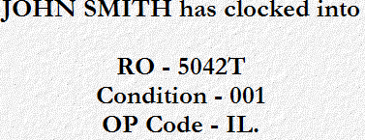
A confirmation message will show on the screen telling you which RO, condition and op code you have just logged into

TTE

Technician Time Entry

Clocking out of a Repair Order

- Type in TTE in the Task Box

- Technician
  - Enter your Technician #
  - You can also use the Arrow to look it up and click on your name with the mouse

- The RO you have been working on will be displayed in the center of the screen

- Press the Clock Out button to clock out of the RO

